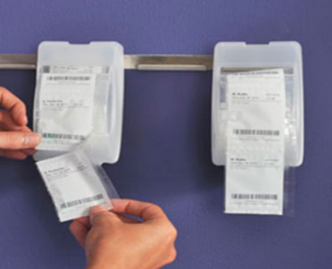

 Management Reports

 Training and Support

 Team Based Approach



The service includes access to the

O’Sullivans online system, and a

fully programmed tablet device for

use in medicines administration, management and reporting.

We supply electronic

tablets with pre-

installed software to

each Care Home,

as well as ongoing

training and support

onsite and through a dedicated phone line.

.

A fully secure, cloud based integrated system to facilitate better medications management and communication between Nurses, GPs and Pharmacists.

Medicines are

dispensed in

barcoded MDS

pouch systems.

Each pouch contains

the medicines to be

administered to the

patient at the prescribed time of day.

Clinical information

is accessible in real-time at the patient’s bedside, any changes made are immediately communicated to the pharmacy and corresponding records adjusted

Accessing patient files on the tablet device at point of care allows nurses and doctors to make

informed decisions in a timely manner.

The system provides a complete description of a patient's history at the bedside.

**Training and Support**

A pharmacist will be available throughout the transition period to provide training to all staff.

Dedicated team and phone line to answer all queries

Access to O'Sullivans own out of hours pharmacy, until 11pm seven days a week

 Reducing Costs by Improving Efficiency.

 Better Medication Administration.

 Dedicated care home dispensary and staff.

.

 Real time, up to date information

 Tablet images incorporated for ease of tablet identification

.

 Secure delivery service

O’Sullivan’s EasyMed for Care Homes

Our Goal – to make medication administration better, safer and more efficient for all providers through the use of monitored dosage systems and our dedicated medicines management software.

 Bespoke Software System

 Reduces Risk

 Improves efficiency

A person looking at each other

Description generated with high confidence